“FANCY UP” YOUR THANKSGIVING TABLE:
JUST ADD WATER
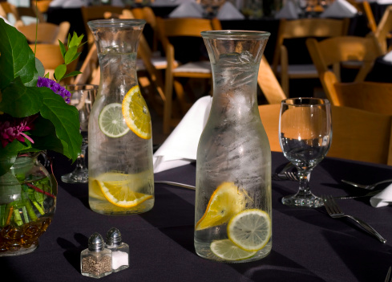

Sure, water’s good for your health. But H2O can also pack a powerful place setting at your Thanksgiving table.

Choose pitchers, carafes, or special-occasion artisan bottled water in all shapes and sizes.

Here are a few questions to get your creativity flowing:
How many people are you hosting? _____
Individual waters or family-style? _____
Earthy or elegant? _____

You’re ready to play.

A day or two before Thanksgiving, play around with pitchers, carafes, and special glassware at place settings and as centerpieces. It’s amazing how water vessels add sparkle, weight and charm to the table.

There are two basic strategies:

Individual. A dressed-up water setting at each seat is a special way to take care of your guests. You can wrap napkins around the glass in a creative way, add a sprig of mint or lemon slice, or use the water as a place card prop.

Family-Style. Larger vessels make interesting centerpiece anchors. Try one on each end of the table, or bunch a couple of carafes (using “add ins” — below) together in the center with outdoor elements like bittersweet branches or pussy willows. The height brings drama and fills in flower and candle arrangements.

Add-ins Anyone?

For an added design dash, put a slice of orange, lemon or a sprig of mint in each water glass. Give the kids fancy paper straws. Or freeze up some ice cubes with pomegranate seeds in them.

More pie?

Traditional holiday beverages can be full of unnecessary sugar (think punch, and hot or sparkling cider). Switching these for water might free up some calories for an extra helping of _________.

Minding your middle? Experts say drinking water before a meal helps you feel full faster, and may also boost metabolism.

Watch it boost your table’s energy level, too.

Will water have a seat at your Thanksgiving table this year? We’d love to see it. Snap a pic and post in the comments box below.

And for help finding the perfect special-occasion water, as always, consult our Better Beverage Finder, for dozens of water choices every Thanksgiving guest can love.

Happy holiday!

